AR Pocket Trainer

MALIK MUNEEB SHAHID

JUNAID AHMED



DEPARTMENT OF COMPUTER SCIENCES

COMSATS UNIVERSITY ISLAMABAD,

ATTOCK CAMPUS – PAKISTAN

SESSION 2019-2023

AR Pocket Treainer

*Undertaken By:*

JUNAID AHMED

CIIT/FA19-BSE-032/ATK

MALIK MUNEEB SHAHID

CIIT/FA18-BSE-034/ATK

*Supervised By:*

Mr. Waqas Ahmed

A DISSERTATION SUBMITTED AS A PARTIAL FULFILLMENT OF THE

REQUIREMENTS FOR THE DEGREE OF BACHELOR OF SCIENCE IN

SOFTWARE ENGINEERING

DEPARTMENT OF COMPUTER SCIENCES

COMSATS UNIVERSITY ISLAMABAD,

ATTOCK CAMPUS – PAKISTAN

SESSION 2018-2022

**UNDERTAKING**

We hereby declare that this software, neither whole nor as a part has been copied out from any source. It is further declared that we have developed this software and accompanied the report entirely based on our efforts. If any part of this project is proved to be copied out from any source or found to be the reproduction of some other. We will stand by the consequences. No portion of the work presented has been submitted of any application for any other degree or qualification of this or any other university or institute of learning.

______________ ______________

Junaid Ahmed Malik Muneeb Shahid

FA19-BSE-032 FA19-BSE-034

Dated: _________ Dated: ____________

**FINAL APPROVAL**

Certified that we have read this project report submitted by Muhammad Ahsan and Rizwan Amjad and it is, in our judgment, of sufficient standard to warrant its acceptance by the Department of Computer Science, COMSATS University Islamabad, Attock Campus, for the BSSE degree.

***Committee:***

1. External Examiner ________________________

Examiner Name

Designation

University Name

1. Supervisor ________________________

Supervisor Name

Designation

University Name

1. Head of the Department ________________________

HoD Name

Designation

University Name

**DEDICATION**

*To our Loving Parents and Teachers*

ACKNOWLEDGEMENT

All praise is to Almighty Allah who bestowed upon us a minute portion of his boundless knowledge by virtue of which we were able to accomplish this challenging task.

We are greatly indebted to our project supervisor “Dr. Yasir Ali Shah”. Without his personal supervision, advice, and valuable guidance, the completion of this project would have been doubtful. We are deeply indebted to him for his encouragement and continual help during this work.

We are also thankful to our parents and family who have been a constant source of encouragement for us and brought us the values of honesty & hard work.

**PROJECT BRIEF**

PROJECT NAME AR_FITNESS TRAINER

ORGANIZATION NAME COMSATS

OBJECTIVE MAKING FITNESS TRAINING EASY AND AFFORDABLE

UNDERTAKEN BY MALIK MUNEEB SHAHID

JUNAID AHMED

SUPERVISED BY MR WAQAS AHMED

Lecturer

CS

COMSATS University Islamabad

STARTED ON 01/04/2021

COMPLETED ON TODO

COMPUTER USED MACBOOK PRO 2015

LENOVO THINKPAD X240

SOURCE LANGUAGE JavaScRIPT,

PYTHON

OPERATING SYSTEM Windows 10

TOOLS USED Git & GitHub,

VSCode,

PYCHARM,

FIREBASE,

DEEPMOTION.

**ABSTRACT**

Working out on your own can be a struggle especially, if you are a beginner and don’t know where to start because there are tons of workout plans out there and each with a million exercises stacked for you to go through and that just makes you lose hope unless you hire a personal trainer who can help you get through the endless jungle called “fitness journey” but the problem is personal trainers are not so “pocket friendly” thereby to tackle this problem and to get you that pack of six, we are going to develop an AR (Augmented Reality) fitness app which will guide you along your journey to become fit and fine.

Our app will start off by calculating your BMI and analyzing your body structure (using Computer Vision) following which will be a diet plan provided to you either calorie deficit or calorie surplus once done with that you will then be directed to workout plan where our app will guide you throughout your workout using Augmented Reality and as you deal with that stuff our app will automatically be keeping track of your progress using Artificial Intelligence and real time body movements recognition and also provide you with analytics that will help you track your progress easily so that you can focus on one and only one goal (yep, you guessed it right) of getting fit.

TABLE OF CONTENTS

Table of Contents

**Literature Review** 20

**Requirement Analysis** 27

**System Design** 35

List of Figures

Figure 1.1 Illustration of Smartly system 2

Figure 4.1 System Use Case diagram 2

Figure 4.2 Mobile App Use Case diagram 2

Figure 4.3 Gateway Use Case diagram 2

Figure 4.4 Mobile App Activity diagram 2

Figure 4.5 Gateway Activity diagram 2

Figure 4.6 Sensor Node Activity diagram 2

Figure 4.7 Actuator Node Activity diagram 2

Figure 4.8 System Sequence diagram 2

Figure 4.9 System Component diagram 2

Figure 4.10 Cloud-based service Component diagram 2

Figure 4.11 Gateway Component diagram 2

Figure 4.12 Sensor Node Component diagram 2

Figure 4.13 Actuator Node Component diagram 2

Figure 4.14 System Deployment diagram 2

Figure 4.15 Entity Relationship Diagram 2

Figure 5.1 Splash Screen on Android 2

Figure 5.2 Login Screen on Android 2

Figure 5.3 Register Screen on Android 2

Figure 5.4 Home Screen on Android 2

Figure 5.5 Account Screen on Android 2

Figure 5.6 Sensor Screen on Android 2

Figure 5.7 Actuator Screen on Android 2

Figure 5.8 QR-Code Scan Screen on Android 2

Figure 5.9 Analytic Screen on Android 2

Figure 5.10 Splash Screen on iOS 2

Figure 5.11 Login Screen on iOS 2

Figure 5.12 Register Screen on iOS 2

Figure 5.13 Home Screen on iOS 2

Figure 5.14 Account Screen on iOS 2

Figure 5.15 Sensor Screen on iOS 2

Figure 5.16 Actuator Screen on iOS 2

Figure 5.17 QR-Code Scan Screen on iOS 2

Figure 5.18 Analytic Screen on iOS 2

Figure 5.19 Gateway Config App Login Screen 2

Figure 5.20 Gateway Config App Wi-Fi Screen 2

Figure 5.21 Gateway Config App Account Screen 2

Figure 5.22 Gateway Config App Security Screen 2

List of Tables

Table 2.1 Comparison of systems 2

Table 3.1 Cross-platform support 2

Table 3.2 Create account 2

Table 3.3 Login 2

Table 3.4 Unique key 2

Table 3.5 Listing gateways 2

Table 3.6 View sensor nodes 2

Table 3.7 View actuator nodes 2

Table 3.8 View the current state of the actuator 2

Table 3.9 Latest reading of sensor node 2

Table 3.10 Sensor analytics 2

Table 3.11 Ready to use IoT hardware 2

Table 3.12 Plug and play hardware 2

Table 3.13 IoT gateway 2

Table 3.14 Sensor nodes 2

Table 3.15 Actuator nodes 2

Table 3.16 Configurable gateway 2

Table 3.17 Adding sensor nodes to the gateway 2

Table 3.18 Adding actuator nodes to the gateway 2

Table 3.19 Connecting gateway to account 2

Table 3.20 Connecting gateway to the internet 2

Table 4.1 System Use Case description 2

Table 4.2 Mobile App Use Case description 2

Table 4.3 Mobile App Use Case description 2

Table 6.1 Test cases for Register Screen 2

Table 6.2 Test cases for Login Screen 2

Table 6.3 Test cases for Gateway Screen 2

Table 6.4 Test cases for Sensor Screen 2

Table 6.5 Test cases for Actuator Screen 2

Table 6.6 Test cases for QR Code Scanner Screen 2

Table 6.7 Test cases for Account Screen 2

LIST OF ABBREVIATIONS

API Application Programming Interface

AP Access Point

HTTP Hypertext Transfer Protocol

IoT Internet of Things

IP Internet Protocol

MQTT Message Queuing Telemetry Transport

MAC Medium Access Control

REST Representational State Transfer

Wi-Fi Wireless Fidelity

**Chapter 1**

**Introduction**

1.1 Introduction:

“If you look good you feel good”

We all agree that fitness is important right? And to help us achieve it a lot of efforts have already been made, there are hundreds of apps available on the internet but what we have noticed is none of them is using augmented reality to guide the user. They are either a well- organized collection of fitness videos or a bunch of exercise plans, not denying the impact they have (technology always has anyway) but we are talking about doubling the magnitude of that impact by giving it a dip in Artificial Intelligence, Augmented Reality and Machine learning.

So, our user will start off by creating his/her account after which they will go through a short body physique inspection with the help of computer vision and for more accuracy we will use body BMI. So, then user will be provided with information of their current state and a matching diet plan after which they will be shown a few introductory videos about what fitness really means and a bit of motivation, phase one ends here. The next step is about bringing things to ground reality where our application will find a suitable workout plan for them, as the user is performing his exercise his body posture and steps will be monitored and recorded, the app will notify him wherever he is doing a mistake and will not count that repetition. There will also be a weekly examination of his body and app will compare his current stats with the ones that were recorded on day one and tell him how much he has achieved since day one along with that he will also be provided with the weekly report of his workout so he can better analyze his track record.

**1.2 Problem Statement:**

Working out on your own can be a struggle especially, if you are a beginner and don’t know where to start because there are tons of workout plans out there and each with a million exercises stacked for you to go through and that just makes you lose hope unless you hire a personal trainer who can help you get through the endless jungle called “fitness journey” but the problem is personal trainers are not so “pocket friendly”. This is the main reason most people get demotivated during their journey and ultimately quit.

1.3 Proposed Solution:

AR Fitness trainer will start off by calculating your BMI and analyzing your body structure (using Computer Vision) following which will be a diet plan provided to you either calorie deficit or calorie surplus once done with that you will then be directed to workout plan where our app will guide you throughout your workout using Augmented Reality and as you deal with that stuff our app will automatically be keeping track of your progress using Artificial Intelligence and real time body movements recognition and also provide you with analytics that will help you track your progress easily so that you can focus on one and only one goal (yep, you guessed it right) of getting fit.

1.4 Motivation:

Our primary driving force behind building this project is to help those peoples who want an effective workout and diet plan but cannot afford professional trainer because of less financial resources. Helping these type of peoples using modern technology is our primary concern for the development of this application.

That way everyone would be able to lead a healthy life and feel good about how they look. We believe that this application can be also used to fight off psychological conditions like body complex and lack of self confidence due to physical appearence. This application will give people to change their lives if they put a little bit of effort and will power in it.

1.5 Tools:

* Visual Studio Code
* Pycharm Professional
* Pycharm Community Edition
* Deep Motion.
* Firebase.
* Expo Cli.

1.6 Frameworks:

* React Native

1.7 Goals and Objetives:

* To create a fitness solution using power of computer vision and AI in order to help a user perform his workout in an efficient manner.
* To ease the process of weight gain/loss for user.
* To maximize the user's focus on his workout and diet routine by minimizing the effort in side tasks.
* To inspire users to become the best version of themselves.
* To provide a balanced diet to user.

**Chapter 2**

# Literature Review

2.1 Introduction:

In this session we are going to discuss some already available projects/applications that resemble our solution. We will be comparing them all with each other on the basis of their pros and cons. In the latter session we are going to take an in depth look at our solution and finally we are going to compare our system with all of the above discussed applications which will provide us with a clear view about why our solution is much optimized version of all the available solutions.

2.2 Availa ble Systems:

There are variety of different fitness software abailable to us today and all of them have their own uniquenesses and limitations. We will be looking at these applications in detail below:

Pro-Fitness:

The PRO-Fitness app is designed specifically for fitness trainers who lead personalized workouts.This application allows its users to:

* keep a training schedule
* customer base
* create customized workouts
* create custom exercises
* share exercises with other trainers

in addition the application has certain other features like:

* timer
* measurements and their dynamics
* customer profile with basic information
* muscle groups

Limitations:

* Does not support body recognition using computer vision.
* Does not monitor exercises using computer vision.
* Does not propose diet plan for the user to follow on the basis of his BMI and body analytics.
* Does not provide Provide user with progress tracking reports.
* Does not contain BMI calculator
* Does not have Augmented reality based exercise guidence plan.

30 Days Fitness:

30 Day Fit Challenge Workout increases exercise intensity step by step, so you can easily stick daily workouts. Don't need to go to gym, just use your body weight and take a few minutes a day, 30 Day Fit Challenge Workout will greatly help you keep fitness and lose weight effectively. It has 360 degrees exercise tutorials for 30 days fitness

Limitations:

* Does not support body recognition using computer vision.
* Does not monitor exercises using computer vision.
* Does not propose diet plan for the user to follow on the basis of his BMI and body analytics.
* Does not provide Provide user with progress tracking reports.
* Does not contain BMI calculator
* Does not have Augmented reality based exercise guidence plan.

JEFIT – Gym workout and plan and log tracker:

Jefit has an execise libarary with vast number of execises and workout plans .With a built in rest timer and an intuitive exercise logging system it allows users to to create his/her own workout plan manually with flexibilty and vastness.

Limitations:

* Does not support body recognition using computer vision.
* Does not monitor exercises using computer vision.
* Does not propose diet plan for the user to follow on the basis of his BMI and body analytics.
* Does not provide Provide user with progress tracking reports.
* Does not contain BMI calculator
* Does not have Augmented reality based exercise guidence plan.

7 Minute Workout:

The app consists of only 12 exercises to be done for 30 seconds, with 10 second breaks between each exercise. All a user needs is a chair and a wall. Repeat 2-3 circuits depending on how much time you have. It allows user to perform exercises easily at home or at office.

Features contain:

* Google Fit support
* Voice guidance
* Adjustable circuit time
* Adjustable rest time
* Character and UI design
* Workout log shows your complete workout time

Limitations:

* Does not support body recognition using computer vision.
* Does not monitor exercises using computer vision.
* Does not propose diet plan for the user to follow on the basis of his BMI and body analytics.
* Does not provide Provide user with progress tracking reports.
* Does not contain BMI calculator

2.3 Proposed System:

Our proposed system will be a complete package comprising of all the neceassary tools required to help a user with hir/her fitness routine. From body analysis using computer vision to BMI canculation to diet plan suggestions to workout plan to exercise monitoring. Every thing will be available to the user under the ruberic of AR Fitness Trainer.

Our system will be majorly made up of four components. Details about these components are discussed below:

2.3.1 USER INTERFACE – using React Native:

UI will be interactive mobile app that will allow the user to interact with the system. Through UI user will be able to manage his plans and check monthly/reports. Moreover he will also be able to navigate between different screens as per requirements. For instance : if our user wants to activate camera for exercise recognition, he will be able to do it with the help of the virtual buttons given on the sreen.Similarly other operations like reports, AR guide etc will all be accessable to the user using system UI.

2.3.2 Machine Learning Model:

Machine learning model will be working side by side with the rest of our system to ensure he is performing all the reps accurately and utilizing the full potential of his body to perform that specific exercise. In addition it will also :

* Recoginze body type using computer vision.
* Suggest a diet plan to user, either, calorie surplus or calorie deficit.
* Suggest a workout plan for the user.
* Count number of reps of an exercise performed correctly.
* Monitor exercise accuracy in real time.

2.3.3 FireBase for Database Integration:

The users data has to go somewhere right? So we will be using firebase for the data storage. There are two benefits of using firebase.

* Our application will not clutch user’s physical storage on the device.
* In case users mobile phone is lost/destroyed he can still have access to his records and start right where he left.

2.3.4 Sensors and actuators:

Our system will be utilizing the following resources of a cell phone to perform smoothly:

1. Camera
2. Speaker

Camera will be used to track user’s exercise progress and to monitor his performance during an exercise. Speakers on the other hand will be used to notify the user if he exceeds the thresh-hold of wrongly performed reps of an exercise exercise.

2.4 Comparison:

|  |  |  |  |  |  |
| --- | --- | --- | --- | --- | --- |
| **Functionalities** | **Proposed** | **Pro Fitness** | **Workout plan** | **30 Days fitness challenge** | **7 Minute workout** |
| AR Trainer | ✔ | ✖ | ✖ | ✖ | ✖ |
| Body Physique Recognition | ✔ | ✖ | ✖ | ✖ | ✖ |
| Workout Reminder | ✔ | ✖ | ✖ | ✔ | ✖ |
| Diet Plan | ✔ | ✖ | ✖ | ✖ | ✖ |
| Video Recommendations | ✔ | ✖ | ✖ | ✖ | ✖ |
| Progress tracker | ✔ | ✔ | ✖ | ✖ | ✔ |
| Weekly comparison | ✔ | ✖ | ✖ | ✖ | ✖ |
| Exercises | ✔ | ✔ | ✔ | ✔ | ✔ |

**Chapter 3**

Requirement Analysis

3.1 Introduction

In the following chapter, we will go through the requirements of our system. These Include the:

1. Functional Requirements
2. Non Functional Requirements

We will be looking at functional requirements in first section and non functional requirements in second section.

3.2 Functional Requirements

Listed below are the functional requirements of AR Pocket Trainer.

* The application shall run on both android and iOS platforms.
* The user shall be able to create account.
* The user shall be able to log into the system.
* The application shall be able to determine user’s body type using computer vision.
* The application shall be able to propose a diet plan according to user’s BMI and body type either calorie deficit or calorie surplus.
* The application shall be able to propose a a workout plan to user on the basis of his body type and BMI.
* The application shall be able to recognize exercise that the user is performing.
* The application shall be able to prompt user if he performs a rep incorrectly.
* The user shall be able to check his progress via monthly or weekly reports.
* The application shall be able to remind user about his workout time.

3.3 Functional Requirements Analysis:

Table 3.1 Cross-platform support

|  |  |
| --- | --- |
| **Identifier** | **FR-1** |
| **Title** | Cross platform support |
| **Requirement** | The Mobile App should run on both Android and iOS. |
| **Source** | Users |
| **Rationale** | -- |
| **Restrictions and Risk** | -- |
| **Dependencies** | -- |
| **Priorities** | Low |

Table 3.2 Account Creation

|  |  |
| --- | --- |
| **Identifier** | **FR-2** |
| **Title** | Account Creation |
| **Requirement** | The user shall be able to create his account. |
| **Source** | Users |
| **Rationale** | The application requires authorization of the user to access and store his data. |
| **Restrictions and Risk** | The user must have a unique and valid email. |
| **Dependencies** | -- |
| **Priorities** | High |

Table 3.3 Log-in Functionality

|  |  |
| --- | --- |
| **Identifier** | **FR-3** |
| **Title** | Log-in functionality |
| **Requirement** | The registered user shall be able to log into the app. |
| **Source** | Users |
| **Rationale** | To allow user access to his data and to store his future data. |
| **Restrictions and Risk** | The user must already have an existing account on our application. |
| **Dependencies** | -- |
| **Priorities** | High |

Table 3.4 Physique Recognition

|  |  |
| --- | --- |
| **Identifier** | **FR-4** |
| **Title** | Physique Recognition |
| **Requirement** | The application shall recognize user’s body physique using computer vision. |
| **Source** | Users |
| **Rationale** | To determine user’s body type. |
| **Restrictions and Risk** | The device must have a camera |
| **Dependencies** | -- |
| **Priorities** | High |

Table 3.5 Diet Plan Suggestion

|  |  |
| --- | --- |
| **Identifier** | **FR-5** |
| **Title** | Diet Plan Suggestion |
| **Requirement** | The application shall propose a calorie surplus or calorie deficit diet plan to user. |
| **Source** | Users |
| **Rationale** | To propose a suitable diet plan to user for his fitness routine |
| **Restrictions and Risk** | The user must have calculated his BMI previously. |
| **Dependencies** | FR-4 |
| **Priorities** | Medium |

Table 3.6 Propose workout plan

|  |  |
| --- | --- |
| **Identifier** | **FR-6** |
| **Title** | Proposing Workout Plan |
| **Requirement** | The application shall provide user with a suitable workout plan. |
| **Source** | Users |
| **Rationale** | To provide user with a suitable diet plan. |
| **Restrictions and Risk** | The user must already have a diet plan. |
| **Dependencies** | FR5 |
| **Priorities** | Medium |

Table 3.7 Exercise Recognition

|  |  |
| --- | --- |
| **Identifier** | **FR-7** |
| **Title** | Exercise Recognition |
| **Requirement** | The application shall recognize the exercise that user is performing. |
| **Source** | Users |
| **Rationale** | To determine the exercise user is performing. |
| **Restrictions and Risk** | The user must have a camera in his device |
| **Dependencies** | -- |
| **Priorities** | High |

Table 3.8 Incorrect Exercise Prompt

|  |  |
| --- | --- |
| **Identifier** | **FR-8** |
| **Title** | Incorrect exercise prompt |
| **Requirement** | The application shall promtp user if they perform wrong exercise rep. |
| **Source** | Users |
| **Rationale** | To prevent user from performing wrong exercise. |
| **Restrictions and Risk** | -- |
| **Dependencies** | FR-7 |
| **Priorities** | High |

Table 3.9 Progress Reports

|  |  |
| --- | --- |
| **Identifier** | **FR-9** |
| **Title** | Progress Reports |
| **Requirement** | The application shall provide user with monthly or weekly progress reports. |
| **Source** | Users |
| **Rationale** | To help user track his progress. |
| **Restrictions and Risk** | -- |
| **Dependencies** | -- |
| **Priorities** | Medium |

Table 3.10 Workout Reminder

|  |  |
| --- | --- |
| **Identifier** | **FR-10** |
| **Title** | Workout Reminder |
| **Requirement** | The application shall remind user about his workout time. |
| **Source** | Users |
| **Rationale** | To prompt user about his workout time. |
| **Restrictions and Risk** | -- |
| **Dependencies** | -- |
| **Priorities** | Medium |

3.4 Non Functional Requirement

3.4.1: Performance:

* The application shall provide optimal performance since it has to perform realtime functionalities. So if the performance decreases the user wont be able to know about his mistakes in due time.

3.4.2: Recoverability:

* The application shall be able to recover user data in case the user misplaces his device due to any reason.

3.4.3: Scalablity:

* The system shall allow user to add more workout remiders if the wish.

3.4.4: Usability:

* The system must be easily usable by primary user persona even if they don’t have extensive knowledge of technology.

3.4.5: Reliability:

* The systme must identify user’s exercise coreectness with accuracy of 90%.

3.4.6: Availability:

* The application must be available to user 24/7 so that he can perform his workout anytime and anywhere he want.

s

**Chapter 4**

System Design

4.1 Introduction:

In this chaper we are going to take a look at the detailed working of our application using visual representation. The first section of this chapter will deal with UML use case behavioral diagrams by explaining complete working of the system and showing how the system will deal with different events.

In latter section we will be explaining the structural details of our system using UML structural diagrams. This section will also represent the overall architecture of our application and discuss the details of sub-system (if any).

4.2 Use Case Diagram:

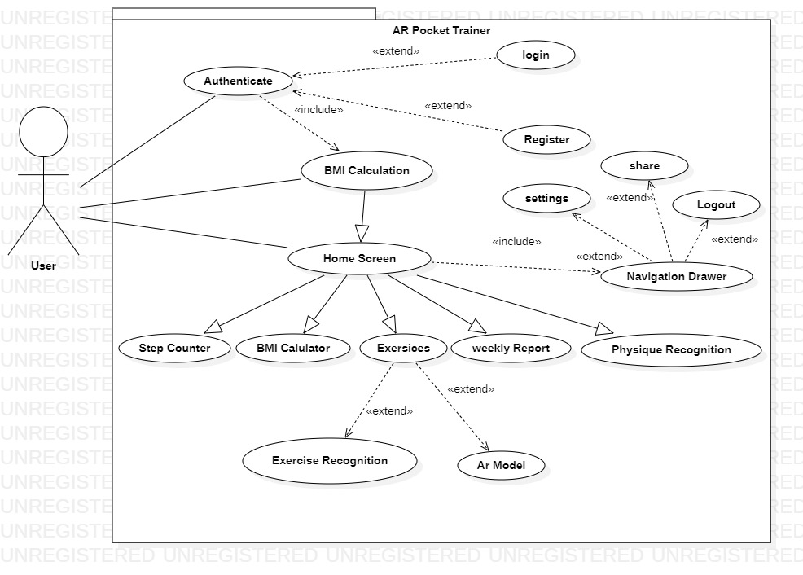

Figure 4.1: System Use Case Diagram

Figure 4.1 represents use case diagram of the complete system. Details about the use case are given below in Table 4.1.

Table 4.1 : System Use Case Description

|  |  |
| --- | --- |
| **Use Case** | **Description** |
| Authentication | Users can create a new account and login into the system from the mobile app. Without the account, the user cannot access the system. |
| BMI Calculation | Users can calculate its BMI which is used for Exercises and recommending steps. |
| Physique Recognition | User can calculate its BMI using Physique recognition. Which actually tells BMI on basis of height and width. |
| Step Counter | Users can Track record of its steps using steps counter also it tells how much calories you burn. |
| Home screen | Users should be able to Navigate to all the screens from home screen of app. |
| Navigation Drawer | Users should be able to navigate to all screen form navigation drawer and also go to setting and do logout. |
| Exercise | Users should be record reps of defined exercises with correction using Ar Model. |
| Ar Model | User should be able to check how to perform specific steps from Augmented reality character |

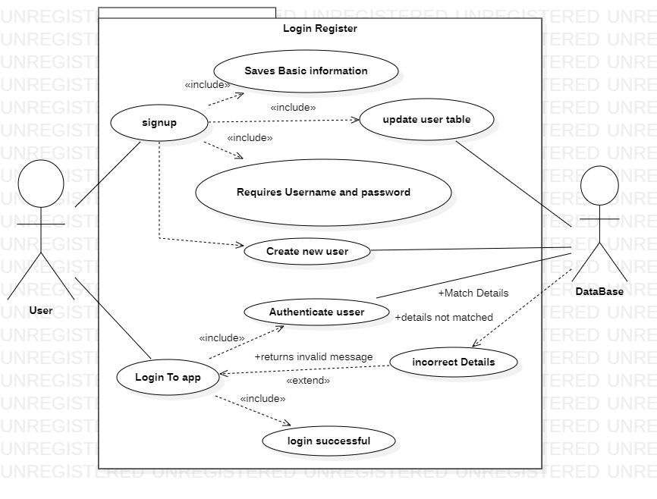

Figure 4.2: Log in/Sign up Use Case Diagram

Table 4.2: Log in/Sign Up Use Case Description

|  |  |
| --- | --- |
| **Use Case** | **Description** |
| Sign up | Users can create a new account and login into the system from the mobile app. Without the account, the user cannot access the system. |
| Login | If user is already registered; then he/she will be able to use the system by entering valid username and password. |
| Update user table | App will update the database table with user information. |
| Invalid details | If user information is wrong then pop-up shows up with the message that invalid username password. |
| Login successful | Users should be able to view the home screen after this message. |

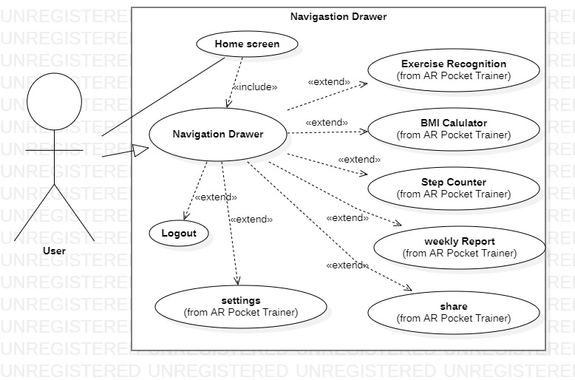

Figure 4.3: Navigation Drawer Use Case Diagram

Table 4.3: Navigation Drawer Use Case Description

|  |  |
| --- | --- |
| Home screen | Users can go to the Navigation Drawer using home screen . |
| All the screens | User should be able to navigate to all the screens using navigation drawer. |
| Logout | User should be able to logout from account using navigation drawer. |
| Share | User can share app using app link. |
| settings | User should be able to access app settings using navigation drawer. |

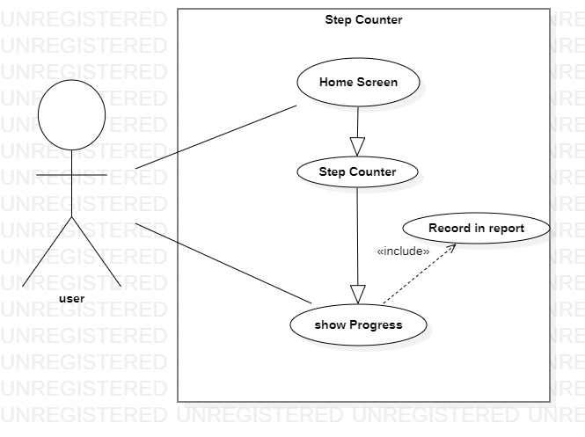

Figure 4.4: Step Counter Use Case Diagram

Table 4.4: Step Counter Use Case Description

|  |  |
| --- | --- |
| **Use Case** | **Description** |
| Home screen | Users can goto the step counter screen using home screen . |
| Step Counter | Users can check its todays steps from progress bar on step counter screen. |
| Record in reports | App record all the progress to generate reports. |

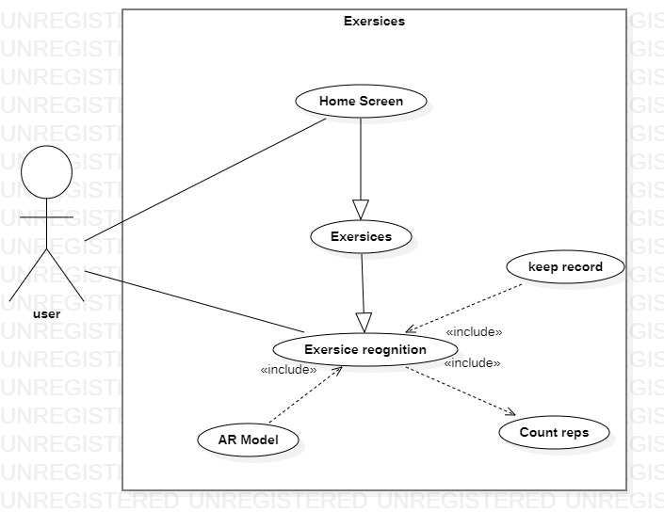

Figure 4.5: Exercise Recognition Use Case Diagram

Table 4.5: Exercise Recognition Use Case Description

|  |  |
| --- | --- |
| **Use Case** | **Description** |
| Home screen | Users can go to the Exercises screen using home screen . |
| Exercise Screen | User should be able to select exercises. |
| Exercise Recognition | This can record user reps of particular exercise in right and wrong manner. |

4.3 Activity Diagram:

4.3.1: Exercise Recognition, Activity Diagram

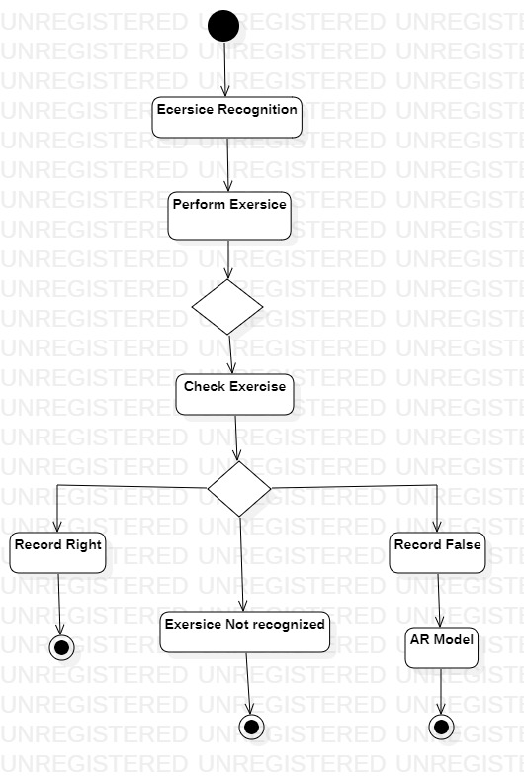

4.3.2: Step Counter Activity Diagram:

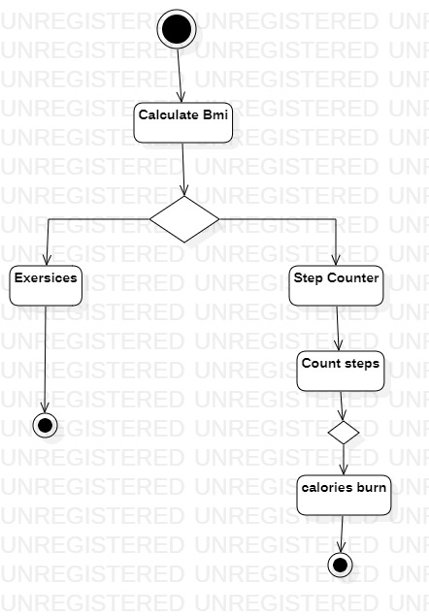

4.4: Sequence Diagrams

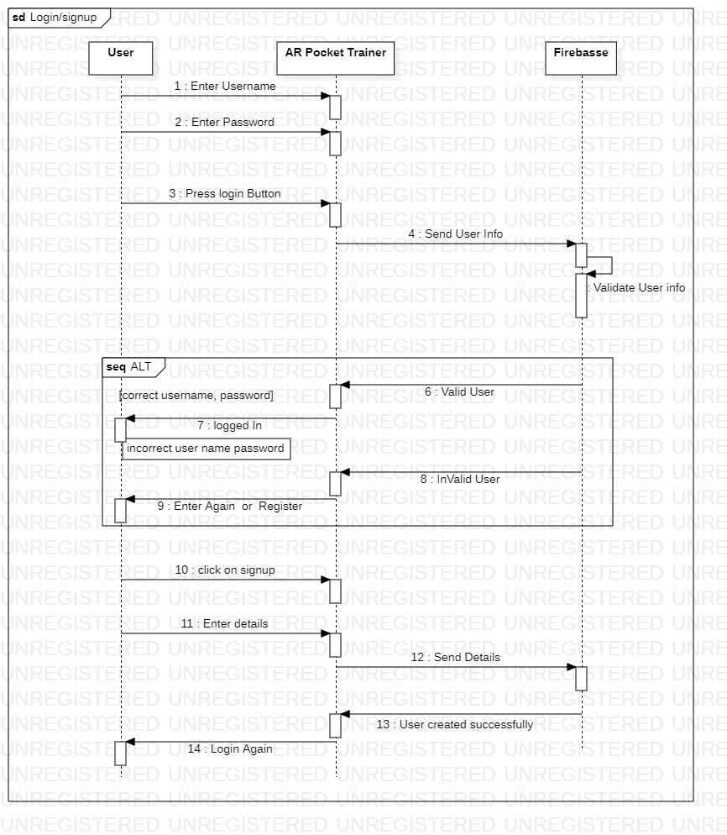

Figure 4.6 : Log In/Sign up Sequence Diagram

The diagram given above depicts that, a user will start off by entering his credentials in respective fields. Following his actions, the application will authenticate the information from firebase server.if the server authenticates that its a valid user, system will grant him access to the account.Otherwise he will have to re enter his information. In case user is new and he selects the ‘sign up’ option. Then the syste will ask him for his details. Upon tapping sign up button he willl be registered.

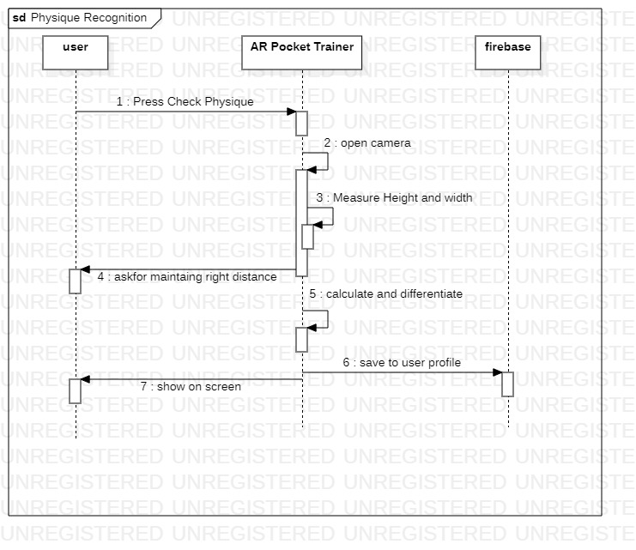

Figure 4.7 : Physique Recognition Sequence Diagram

In this diagram, the user will enter the physiqie recognition model by tapping on the respective button. Once inside the application will access the user’s camera. Right aftwewards.The model will calculate height and width of the user, save it to his profile on firebase and display it to the user on the screen.

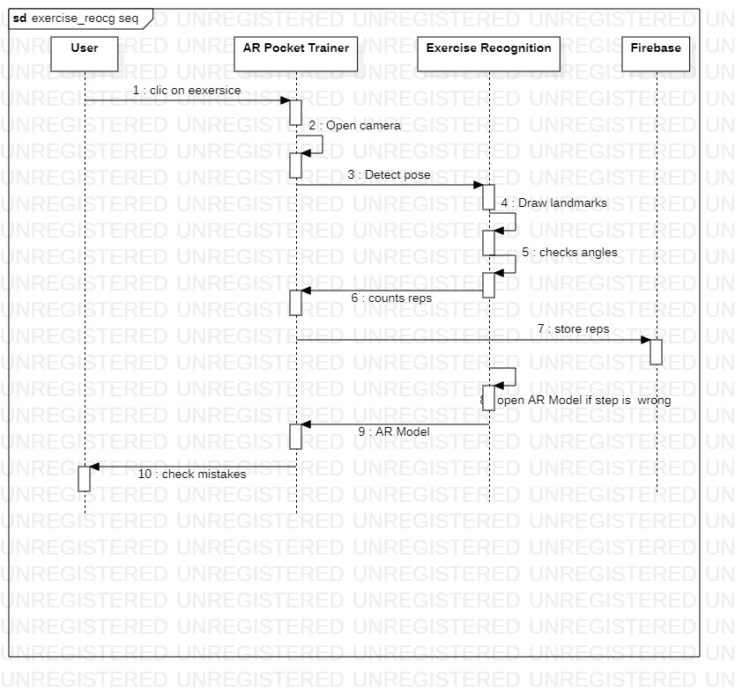

Figure 4.8 : Exercise Recognition Sequence Diagram

The diagram above depicts that once the user is inside this component. The application will open camera and the model will start monitoring his exercise. As long as user keeps performing the exercise correctly, application will keep recording his information and maintain the logs in the background. In case the user performs the exercise incorrectly the application will promt the user in real time and would not count the wrongly performed rep.

4.5: Deployment Diagram:

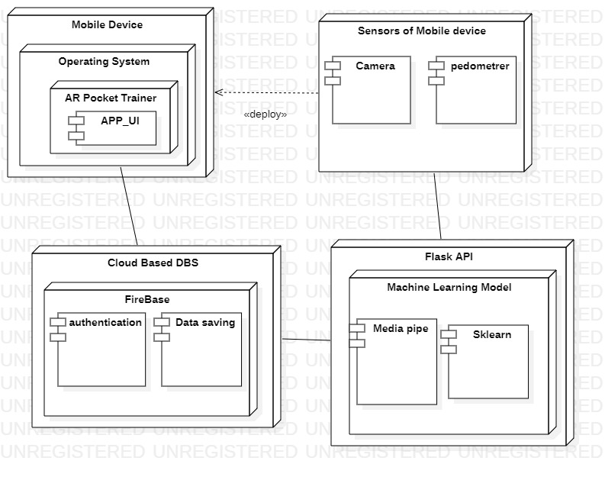

Figure 4.9 : AR-Deployment Diagram